**NEPAL COLLEGE OF INFORMATION TECHNOLOGY**

**BALKUMARI LALITPUR**



**(Affiliated To Pokhara University)**

**SUBJECT : Database Management System**

**LAB REPORT # 6**

**TITLE :** Using in-built func tions to be implemented using DML

**Submitted By : Submitted To :**

**Name : Vision Rijal**  **Name :** Amit K. Shrivastava

**Roll No :** 201739 **Department of Software**

**Semester :** 4th  **Date :** 2023/07/04

OBJECTIVE

To practice and implement inbuilt functions to be executed using DML

LAB EXERCISE :

* Creating a Database named 'lab6';

= create database lab6;

= use lab6;

**OUTPUT :**

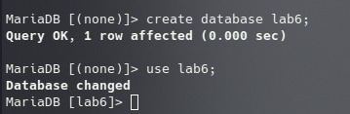

* Creating Tables and Inserting data.

**1) Works Table :**

= CREATE TABLE works (employee_name varchar(50), company_name varchar(50), salary int);

INSERTING DATA :

=insert into works values ('David','First Bank Corporation',16000),('Vision','First Bank Corporation',16000),('Pradipsyste','First Bank Corporation',16000),('Hero','Small Bank Corporation',8000),('Luffy','ABC Bank Corporation',14000);

**OUTPUT :**

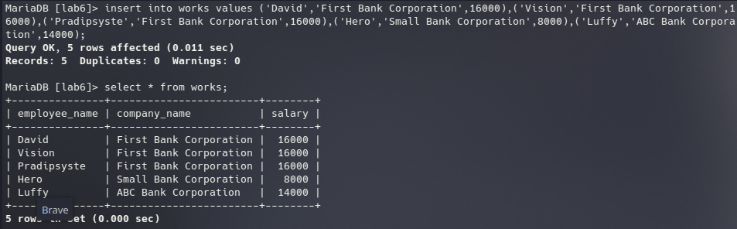

1) Find those companies where the average salary is more than 12000.

= select company_name from works group by company_name having avg(salary) > 12000;

OUTPUT :

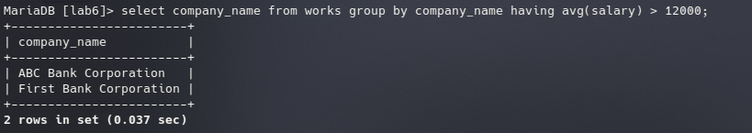

2) Find those companies whose employee on a higher salary, and average than the average salary at First Bank Corporation

= select company_name from works group by company_name having avg(salary) > (select avg(salary) from works where company_name = 'First Bank Corporation');

=

OUTPUT :

3) Find company that has the smallest payroll.

= select company_name from works group by company_name having sum(salary) <= all(select sum(salary) from works group by company_name);

OUTPUT :

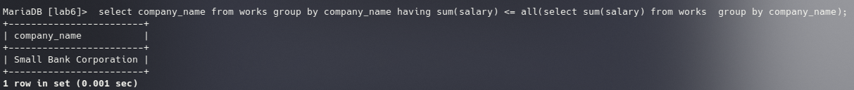4) find those companies who have minimum 3 employees

= select company_name from works group by company_name having count(*) >=3;

OUTPUT:

